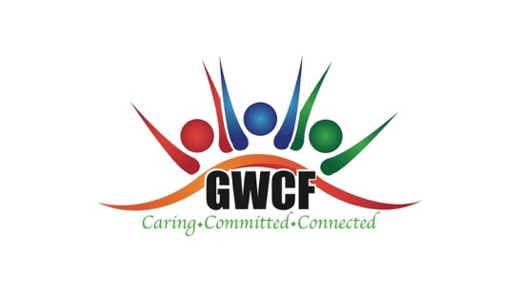

1573 E Livingston Avenue
Columbus, Ohio 43206
(614) 252-7456
www.gwoodfoundation.com
A Non-Profit, Community and Faith Based Organization

Mission Statement: To promote family stability and empowerment through educational, social and community-based services and affordable housing for youth and families residing in the Driving Park Area and surrounding communities within Franklin County, Ohio.

Volunteer Release Form

I, _________________________________________________________________ serve as a volunteer for the Gertrude Wood Community Foundation (GWCF). I volunteer my time in various program areas to support the mission of the GWCF and do so willingly with no expectation of compensation for my efforts.

I fully understand as a volunteer, the GWCF is not responsible for any accidental injury, death or liability that may result from serving as a volunteer. I fully accept all liability for any physical, mental, emotional or bodily harm that may occur as a result of my involvement as a volunteer for the GWCF.

This release form is in effect at all times when representing the GWCF in a volunteer capacity.

Signature: _________________________________ Date: __________________

